A project Report

*ECE 1002 (Fundamental of Electrical And*

*Electronic Engineering )*

*Submitted by*

PRATHAPANI SATWIKA

(20BCD7160)



VIT-AP University ,

Inavolu , Amaravathi ,

Andhra Pradesh-522 237, India .

**Index :**

|  |  |  |
| --- | --- | --- |
| **EXPT NO.** | **EXPERIMENT NAME** | **DATE** |
| **1.** | Analysis of resistance using colour code | 16/01/2021 |
| **2.** | Verification of ohm’s law | 19/01/2021 |
| **3.** | Verification of KCL and KVL | 19/01/2021 |
| **4.** | Verification of current and voltage division rule | 20/01/2021 |
| **5.** | Verification of voltage current power relations for star-delta connected loads | 21/01/2021 |
| **6.** | Calculation of two port network parameters | 23/01/2021 |
| **7.** | Study of characteristics of semiconductor diode transistors | 23/01/2021 |
| **8.** | Design and simulation of various rectifier circuits | 27/01/2021 |
| **9.** | Design and implementation of MOSFET  Voltage amplifier | 28/01/2021 |
| **10.** | Application of Thevenin’s theorem | 28/01/2021 |

**EXPERIMENT NO. : 1**

**Objectives:**

1.To learn Resistor colour code .

2.To determine the stated value of a resistor by interpreting the colour code indicated on the resistor .

3.To verify series and parallel combination of R, C using voltage and current division rule .

**Software Used :** NI Multisim

**Theory :**

**a) Resistor Colour code :**

**1 .** Hold a resistor in your hand . The section with more number of band should be

on left side . After the gap, on right side should be one/two band indicating tolerance or temperature co-efficient .

**2 .** Write on paper in capital letters i.e. , BOGY(GAP)YS, the Colour starting from

left to right .

**3.** Replace the colors with numbers that will be the value of resistor

resistance i.e., 035×104±3% .Cross verification can be done using digital multi-

meter .

**b) Series and parallel combination of R and C**

**1 .** Pick three resistors rated at R1=1kΩ , R2=2kΩ , and R3=3kΩ . Measure their values in the using multimeter .

**2 .** Construct , one at a time , arrangements shown in Fig 2(a) and Fig.2(b) on bread board . Set the supply to 20V .

**3 .** For each arrangement , measure the indicated variables .

**4 .** Repeat the same experiment with three different value of C . Use

a function generator as AC power supply . Measure the RMS value of voltage and

current, using multimeter. To verify series and parallel connection of C and note

down absolute value of reading .

**Circuit diagram(s) :** Resistor comes in 4, 5 or 6-bands. A 6-band resistor is shown in Fig. 1.

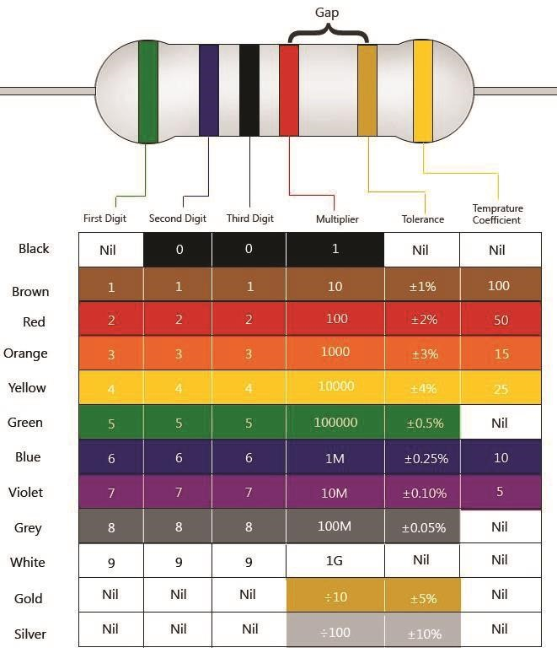

**Figure 1: Colour code for a resistor.**

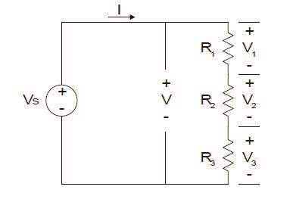

**Figure 2a: Series combination of resistors.**

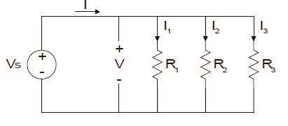

**Figure 2b: Parallel combination of resistors.**

**Results & Observations :**

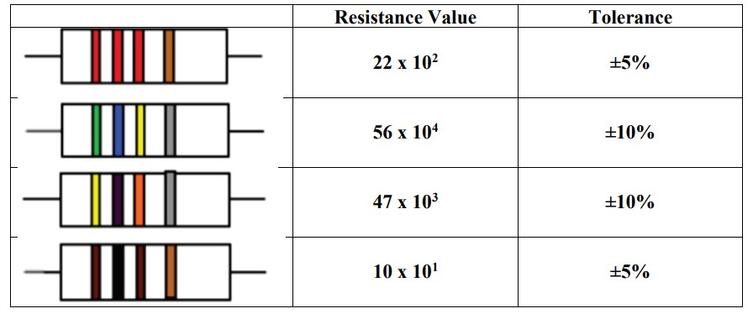

**EXPERIMENT NO. : 2**

**Objective :** To Verify the Ohm’s Law

**Software used :** NI Multisim

**Theory :**

Ohm's law states that **“** at a constant temperature, the electrical current flowing through a conductor is directly proportional to the voltage applied across it, and also inversely proportional to the resistance ” . Mathematically can be written as :

**V ∝ I ;**

**I = V/R ;**

**V = IR**

**Where ,**

**V =** Voltage measured across the conductor

**R =** Resistance of the conductor

**I =** Current through the conductor

**CIRCUIT DIAGRAM :**

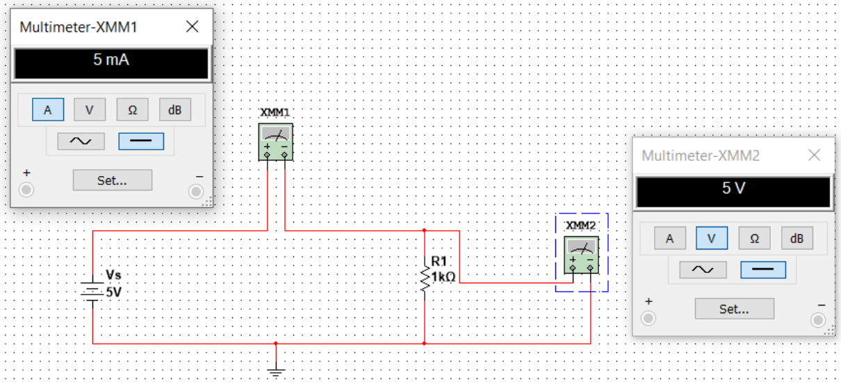

**Results & Observations :**

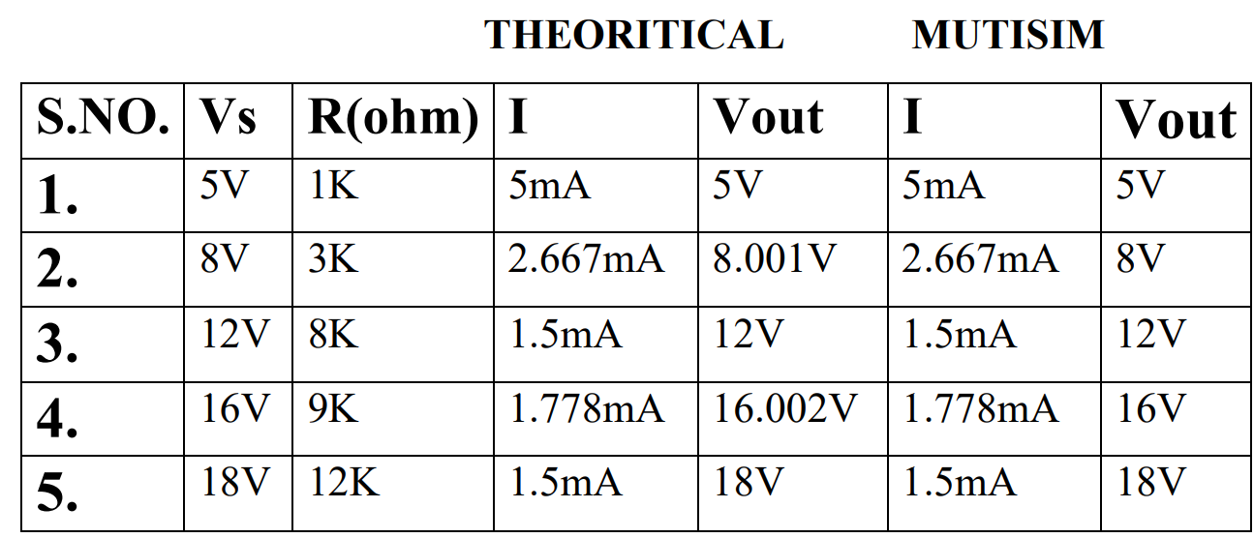

**EXPERIMENT NO. : 3**

**Objective :** To Verify KCL And KVL Equations

**Software used :** NI Multisim

**Theory :**

Junction is a point where three or more components of a circuit meet **.**

**Kirchhoff’s Current Law** states that **“** The sum of the currents flowing towards the junction is equal to the sum of the currents flowing away from the junction ” .

In another way we can say that **“** The algebraic sum of currents at a junction is zero **” .**

**i.e. Σ I = 0 .**

**Kirchhoff’s Voltage Law** states that **“**Thealgebraicsum of all voltages around any closed loop in a circuit is equal to zero**”.**

**i.e. Σ V = 0 .**

In another way we can say that “The sum of all the potential differences around the loop must be equal to zero .

**CIRCUIT DIAGRAM :**

1. **KCL**

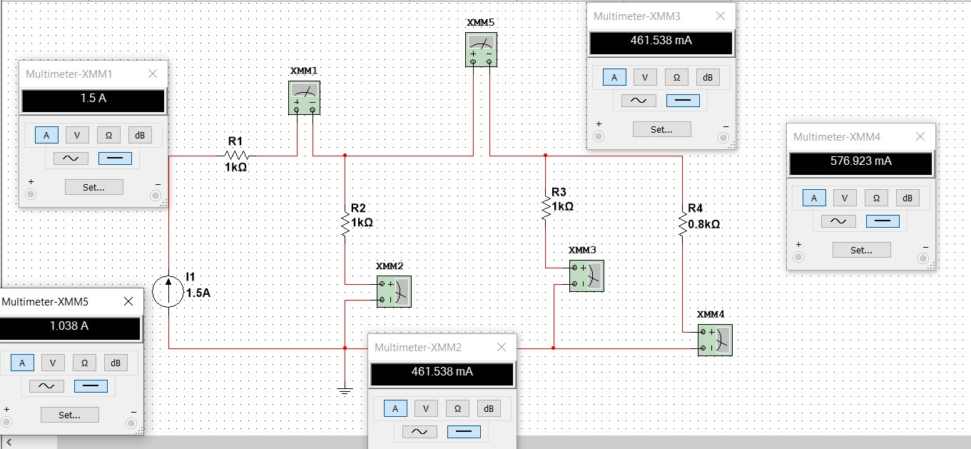

1. **KVL**

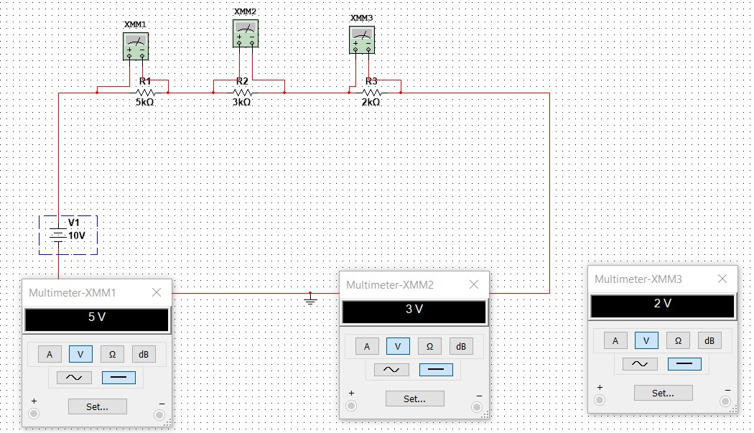

**RESULTS AND OBSERVATIONS :**

1. Experimental Result :

i2=1.038A

Current across R2, i.e. i3 is 461.538mA

Current across R3, i.e. i4 is 461.538mA

Current across R4, i.e. i5 is 576.923mA

Theoretical Result :

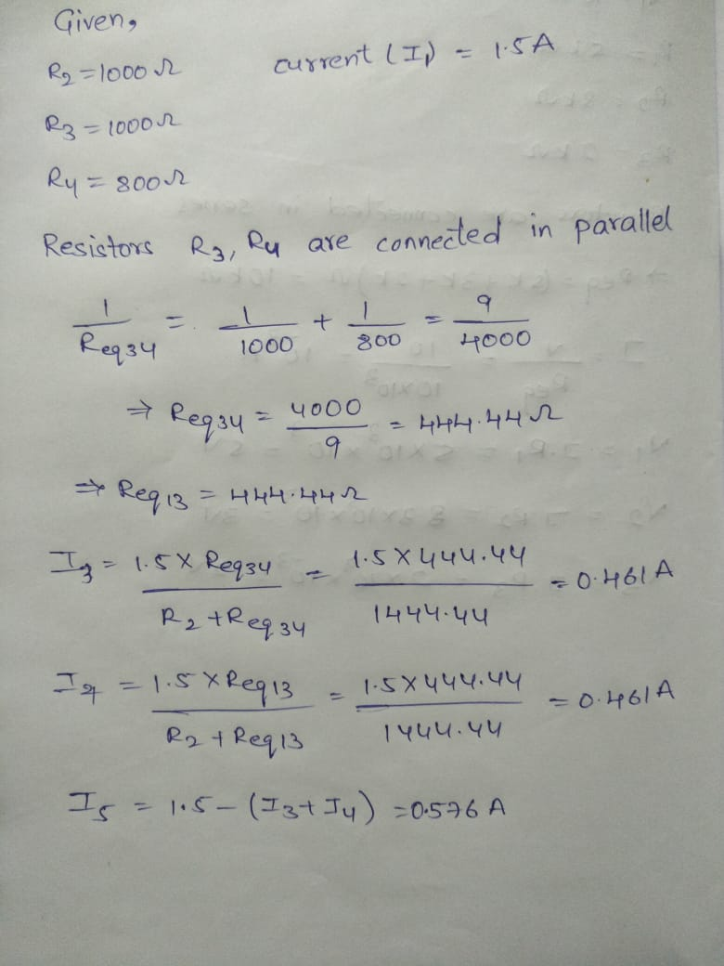

1. Experimental Result :

The voltage across R1 = 5k ohm is 5V

The voltage across R2 = 3k ohm is 3V

The voltage across R3 = 2k ohm is 2V

Theoretical Result :

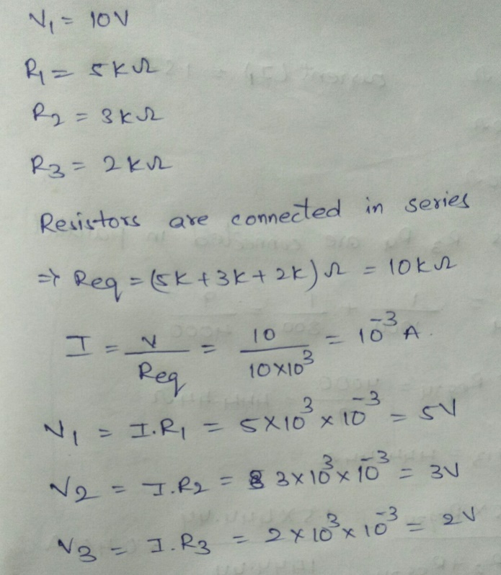

**EXPERIMENT NO. : 4**

**Objective :** To verify the Voltage and Current division Principle .

**Software used :** NI Multisim

**Theory :**

**Voltage division rule** states that **“**The voltage across any resistor in a series connection of resistors is equal to the ratio of the value of the resistor divided by the total resistance of the circuit **”** .

## **Vout = (Vs * R1)/(R1 + R2)**

## **Vout = (Vs * R2) / (R1 + R2)**

**Current division rule** states that **“**The current in any parallel branches of the circuit is equal to the ratio of opposite branch resistance to total resistance , multiplied by total current . The current division rule determines the current across the circuit impedance **” .**

**I1 = (Is * R1) / (R1 + R2)**

**I2 = (Is * R2) / (R1 + R2)**

**Circuit Diagram :**

**Voltage Division Rule :**

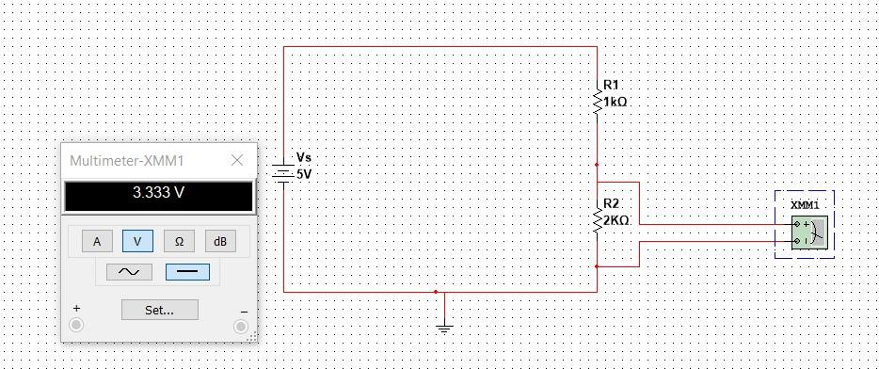

**Circuit – 1**

**Current Division Rule :**

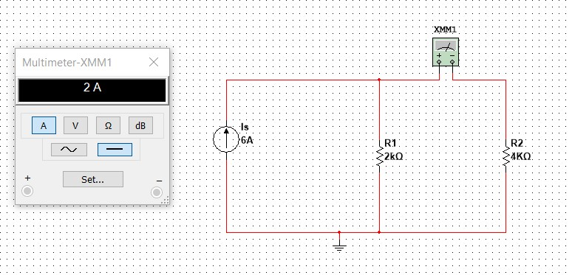

**Circuit - 2**

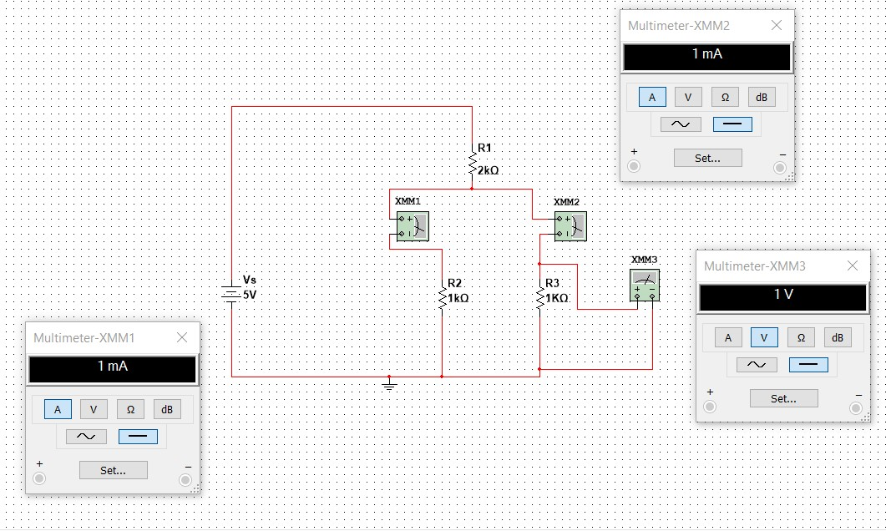

**Circuit – 3**

**RESULTS AND OBSERVATIONS :**

**For Voltage Division Rule :**

**Circuit – 1 :**

|  |  |  |  |  |  |
| --- | --- | --- | --- | --- | --- |
| **S.NO.** | **Vs(V**  **olt)** | **R1(ohm)** | **R2(ohm)** | **THEORITIC**  **AL**  **Vout** | **MULTISI**  **M**  **Vout** |
| **1.** | 5 | 1K | 2K | 3.333V | 3.333V |
| **2.** | 5 | 2K | 3K | 3V | 3V |
| **3.** | 5 | 2.5K | 3.1K | 2.767V | 2.768V |
| **4.** | 5 | 4K | 3.2K | 2.222V | 2.222V |
| **5.** | 10 | 6K | 4.5K | 4.285V | 4.286V |

**For Current Division Rule :**

**Circuit – 2 :**

|  |  |  |  |  |  |
| --- | --- | --- | --- | --- | --- |
| **S.NO.** | **Is(Ampe**  **re)** | **R1(ohm)** | **R2(ohm)** | **THEORITIC**  **AL**  **Iout** | **MULTISIM**    **Iout** |
| **1.** | 6 | 2k | 4k | 2A | 2A |
| **2.** | 3 | 2K | 4K | 1A | 1A |
| **3.** | 5 | 1.2K | 2.5K | 1.621A | 1.622A |
| **4.** | 8 | 1.6K | 1.4K | 4.266A | 4.267A |
| **5.** | 6 | 1.8K | 1.6K | 3.176A | 3.176A |

**Circuit – 3 :**

|  |  |  |  |  |  |  |  |
| --- | --- | --- | --- | --- | --- | --- | --- |
| **Multisim values** | | | | | | | |
| **S.NO.** | **Vs** | **R1(ohm)** | **R2(ohm)** | **R3(ohm)** | **I1** | **I2** | **Vout** |
| **1.** | 5V | 2K | 1K | 1K | 1mA | 1mA | 1V |
| **2.** | 6V | 1K | 2K | 2K | 1.5mA | 1.5mA | 3V |
| **3.** | 8V | 2K | 2K | 1K | 2mA | 1mA | 2V |

**EXPERIMENT NO. : 5**

**Objective :** To verify the voltage, current, power relations for star and delta connected loads.

**Software used :** NI Multisim.

**Theory :**

**Voltages and Currents in Y-Connection :**

The voltage induced in each winding is called the phase voltage and current in each winding is likewise known as phase current. However, the voltage available between any pair of terminals is called line voltage (VL) and the current flowing in each line is called line current (IL).

**Line Voltages and Phase Voltages :**

The p.d. between line 1 and 2 is VRY = ER – EY . Hence, VRY is found by compounding ER and EY reversed. Obviously, the angle between ER and EY reversed is 60°. Hence if ER = EY = EB = say , Eph -the phase e.m.f. , then

|  |
| --- |
| VRY = 2 × Eph× cos( 60°/2) = √3Eph  Similarly, VYB= EY− EB = √3Eph and VBR = EB− ER = √3Eph  Now VRY = VYB = VBR = line voltage, say VL.  Hence, in star connection VL= √3Eph. |

|  |  |
| --- | --- |
| **Line Currents and Phase Currents :** | |
|  | Line current in each line is the same as the current in the phase winding to which the line is connected.  Current in line 1 = IR; Current in line 2 = IY; Current in line 3 = IB  Since IR = IY = IB = say, Iph – the phase current  line current IL= Iph. |
| **Power :**  The total active or true power in the circuit is the sum of the three phase powers.  Total active power = 3 × phase power or P= 3 × Vph Iph cosφ  P = √3VL IL cosφ  **Delta (Δ) or Mesh Connection :**  If the system is balanced then sum of the three voltages round the closed mesh is zero.  This type of connection is also referred to as 3-phase, 3-wire system.  **Line Voltages and Phase Voltages :**  The voltage between lines 1 and 2 as VRY and that between lines 2 and 3 as VYB, we find that VRY lead VYB by 120°. Similarly, VYB leads VBR by 120º.  Let VRY= VYB= VBR = line voltage VL. Then, it is seen that VL= Vph.   |  | | --- | | **Line Currents and Phase Currents :**  Current in each line is the vector difference of the two phase currents flowing through that line.  Current in line No. 1 is found by compounding IR and IB reversed  I1= 2 × Iph× cos (60º/2) = √3Iph  I2 = IB – IY = √3Iph I3 = IB – IY = √3Iph  Since all the line currents are equal in magnitude i.e.  I1 = I2 = I3 = IL   * IL= √3Iph   **Power :**  Total power = 3 × Vph Iph cosφ | | |

**Circuit Diagram :**

**STAR :**

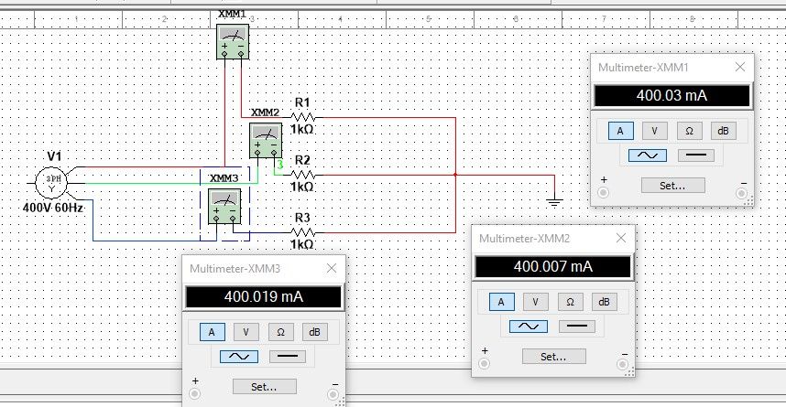

**DELTA :**

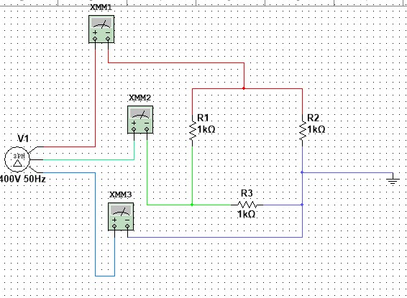

**RESULTS & OBSERVATIONS :**

**STAR :**

|  |  |  |
| --- | --- | --- |
| **Parameters** | **Multisim** | **Theoretical** |
| **VRY** | 692.872V | 692.8V |
| **VYB** | 692.872V | 692.8V |
| **VBR** | 692.872V | 692.8V |
| **IR** | 400.03mA | 400 mA |
| **IY** | 400.07 mA | 400 mA |
| **IB** | 400.019 mA | 400 mA |
| **P1** | 240.037W | 240.0285W |
| **P2** | 240.037W | 240.0285W |
| **P = P1 + P2** | 480.074W | 480.057W |

**DELTA :**

|  |  |  |
| --- | --- | --- |
| **Parameters** | **Multisim** | **Theoretical** |
| **VRY** | 400V | 400V |
| **VYB** | 400V | 400V |
| **VBR** | 400V | 400V |
| **IR** | 692.861mA | 692.820mA |
| **IY** | 692.872mA | 692.820mA |
| **IB** | 692.848mA | 692.820mA |
| **P1** | 240.037W | 239.9995W |
| **P2** | 240.037W | 239.9995W |
| **P = P1 + P2** | 480.074W | 479.999W |

**EXPERIMENT NO.-6**

**Objective :**

* To understand the analysis of a two-port network
* To understand the behavior of a two-port network using parametric analysis.
* To learn the measurement conditions and procedure for two-port analysis.
* **Software Used :** NI Multisim
* **Theory :**

The electrical network with two pairs of terminals is a two-port network . The network inside the box can contain resistors, inductors, capacitors, transformers, transistors and in general any linear circuit device, including depending devices but no independent sources are allowed. The behavior of a linear two-port network is described by impedance (Z), admittance (Y), transmission (ABCD), or hybrid (h) parameter .

**Z - parameters :**

**V1 = Z11I1 + Z12I2**

**V2 = Z21I1 + Z22I2**

**Parameter Condition Name**

**Z11 = V1/I1 I2 = 0 Input Impedance**

**Z21** **= V2/I1 I2 = 0 Transfer Impedance**

**Z12 = V1/I2 I1 = 0 Transfer Impedance**

**Z22 = V2/I2 I1 = 0 Output Impedance**

**Y-parameters :**

**I1 = Y11V1 + Y12V2**

**I2 = Y21V1 + Y22V2**

**Parameter Condition Name**

**Y11 = I1/V1 V2 = 0 Input admittance**

**Y21 = I2 /V1 V2 = 0 Transfer admittance**

**Y12 = I1 / V2 V1 = 0 Transfer admittance**

**Y22 = I2 /V2 V1 = 0 Output admittance**

**H-parameters :**

**V1 = h11I1 + h12V2**

**I2 = h21I1 + h22V2**

**Parameter Condition Name**

**h11 = V1/ I1 V2 = 0 SS input admittance**

**h21 = I2/ I1 V2 = 0 SS forward current gain h12 = V1 / V2 I1= 0 OS reverse voltage gain h22 = I2/ V2 I1 = 0 OS output admittance**

**ABCD-parameters :**

**V1 = AV2 - BI2**

**I1 = CV2 - DI2**

**Parameter Condition Name**

1. **=**  **V1/** **V2** **I2 = 0 OC voltage ratio**
2. **= V1/-I2 V2 = 0 OC transfer admittance**
3. **= I1/V2 I2 = 0 -SC transfer impedance**
4. **= I1/-I2 V2 = 0 -SC current ratio**

**Circuit Diagram :**

**RESU**

**LTS &**

**O**

**BSERVATIONS**

**:**

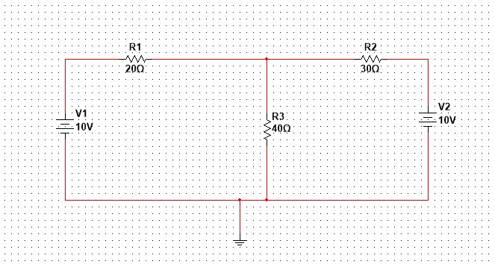

|  |  |  |
| --- | --- | --- |
| **Parameter** | **Calculated Value** | **Measured value** |
| **Z11** | 60Ω | 59.998 Ω |
| **Z21** | 40 Ω | 40.001 Ω |
| **Z12** | 40 Ω | 39.998 Ω |
| **Z22** | 70 Ω | 70 Ω |
| **Y11** | 0.0269 mho | 0.0269 mho |
| **Y21** | 0.0153 mho | 0.01538 mho |
| **Y12** | 0.0153 mho | 0.01538 mho |
| **Y22** | 0.023 mho | 0.023 mho |
| **h11** | 37.142 Ω | 37.14 Ω |
| **h21** | 0.571 | 0.57 |
| **h12** | 0.571 | 0.571 |
| **h22** | 0.0142 mho | 0.0142 mho |
| **A** | 1.5 | 1.499 |
| **B** | -65 Ω | -65 Ω |
| **C** | 0.025 mho | 0.0249 mho |
| **D** | -1.75 | -1.75 |

**EXPERIMENT NO. -7**

**Objective :** To study the input and output characteristics of semiconductor diodes

**Software Used :** NI Multisim **Theory :**

A semiconductor diode is a combination of p and n type semiconductors which in forward bias at which the flow of current during the PN Junction begins increasing rapidly is known as **cut**-in **voltage .** After achieving cutting voltage the increase in current is almost exponential . A diode in reverse bias conducts negligible amount of current in the order of micro amperes .

**I = I0 (e^(v/(****v T ) - 1)**

**Where ,**

I = current flowing through the diode

I0 = reverse saturation current,

q = charge on the electron,

V = voltage applied across the diode,

η = ideality factor (Ge = 1 and Si = 2 ) .

T is the absolute temperature in Kelvin.

The configuration in which the emitter is connected between the collector and base is known as a common emitter configuration. The input circuit is connected between emitter and base , and the output circuit is taken from the collector and emitter **.**

**Circuit Diagram :**

1. **. Diode in Forward Bias :**

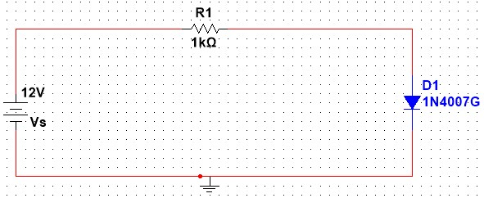

**2. Diode in Reverse Bias :**

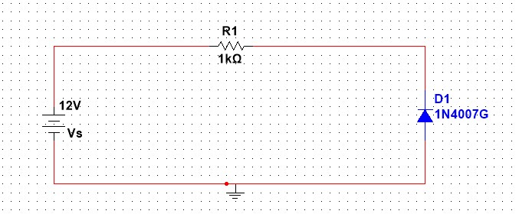

**3. Common Emitter Input Configuration :**

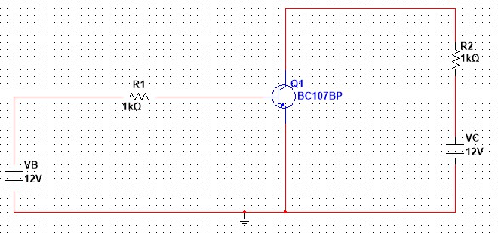

**4 .Common Emitter Output Configuration :**

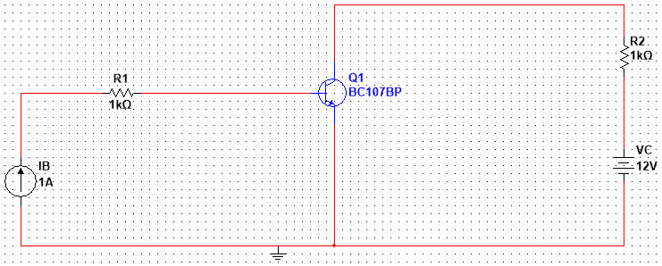

**Results & Observations :**

1. **. Diode is in Forward Bias :**

The Cutting Voltage for the diode is 0.3 V .

Therefore the diode is a Germanium Diode

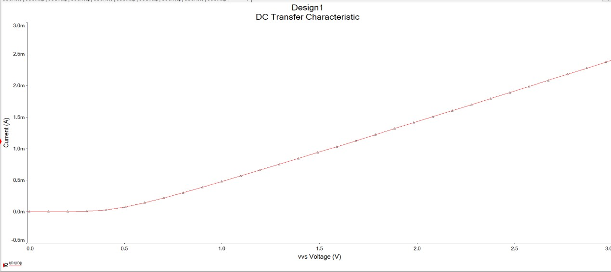

1. **. Diode is in Reverse Bias :**

The leakage current is negligible or zero .

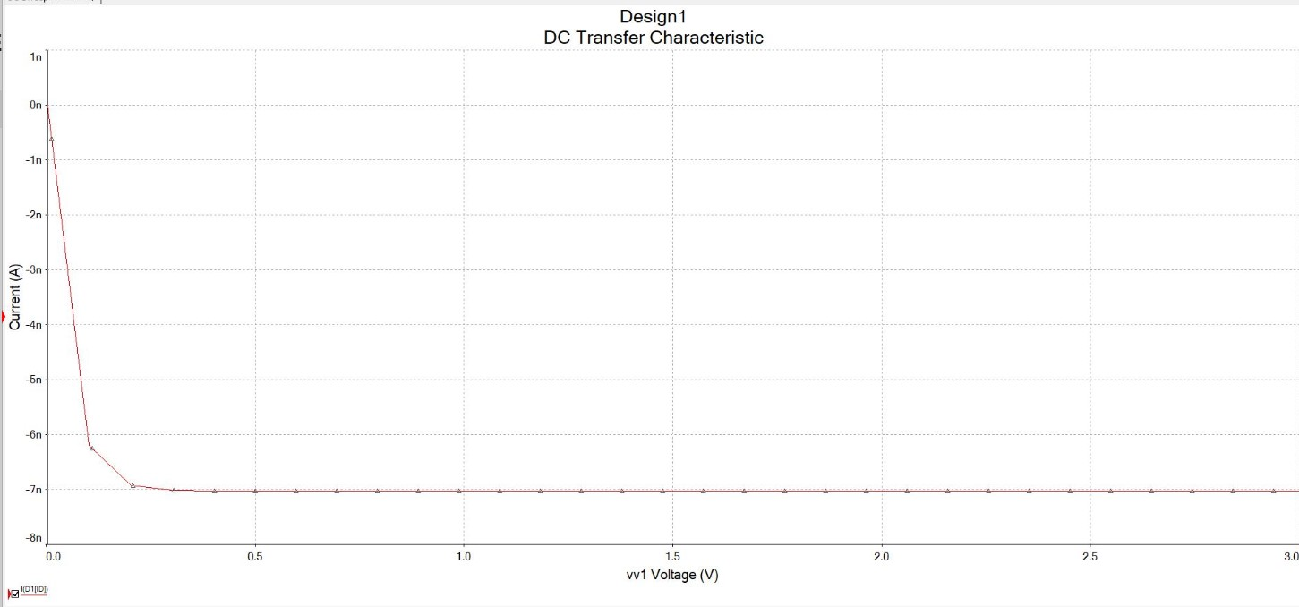

**3. Common Emitter Configuration Input Characteristics :**

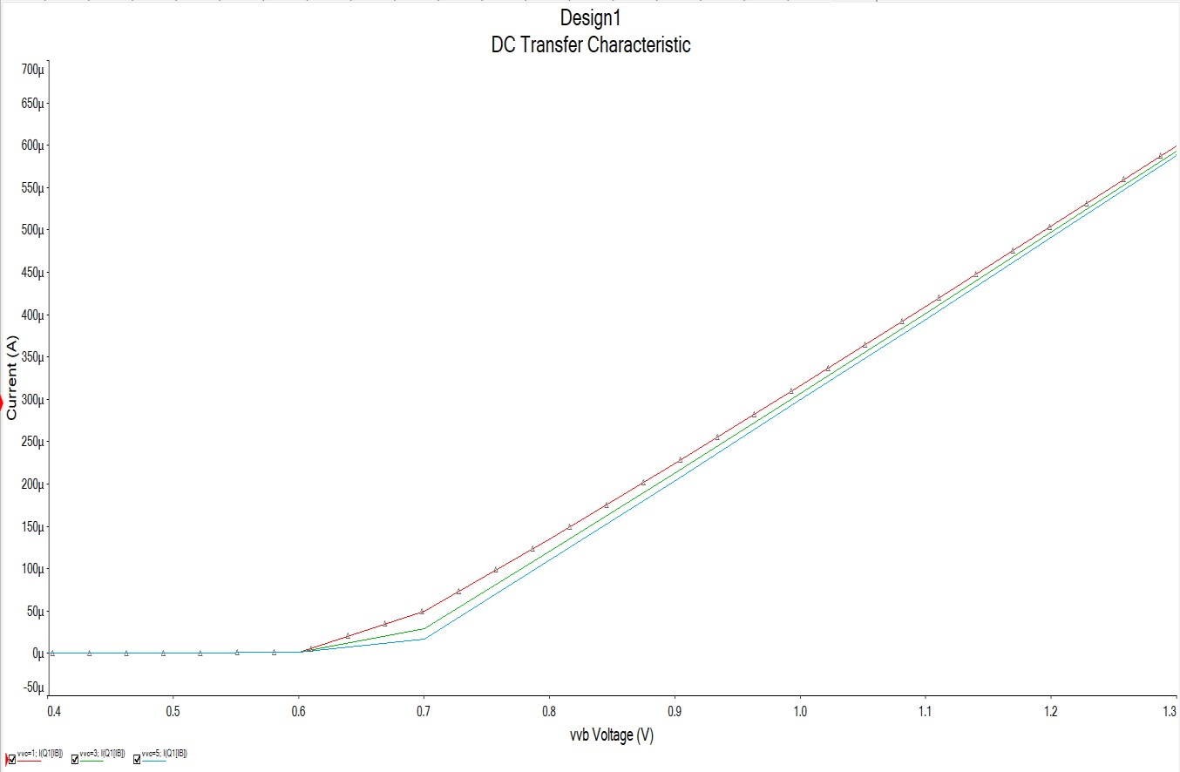

|  |  |  |  |
| --- | --- | --- | --- |
|  |  | **Voltage (VC)** |  |
| **1V** | **3V** | **5V** |
| **Cutting Voltage**  **(Vℽ)** | **0.500V** | **0.506V** | **0.510V** |

**4. Common Emitter Configuration Output Characteristics :**

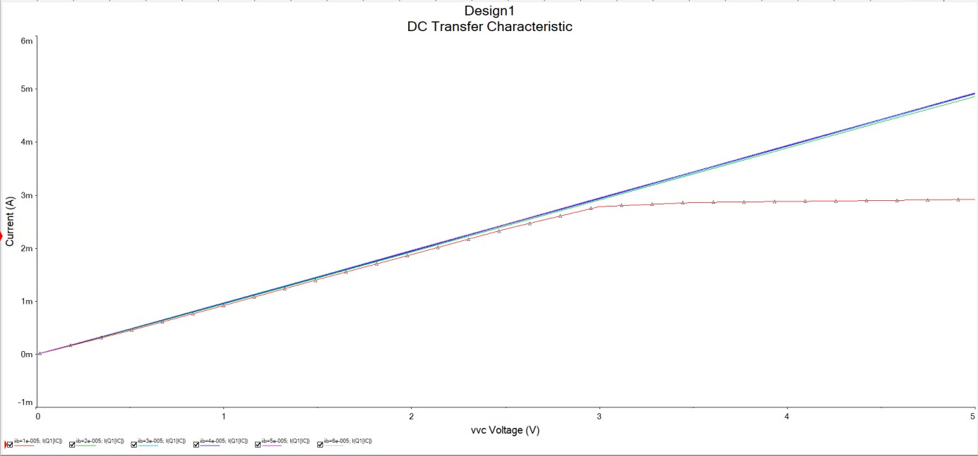

|  |  |  |  |
| --- | --- | --- | --- |
|  |  | **Base Current (IB)** |  |
| **10µA** | **30µA** | **50µA** |
| **Collector Current**  **(IC)** | **2.77mA** | **8.74mA** | **14.46mA** |

**EXPERIMENT NO. – 8**

**Objective :** To design and simulate the half wave rectifier and full wave rectifier.

**Software used :** NI Multisim

**Theory :**

A rectifier is a circuit that converts the Alternating Current (AC) input power into a Direct Current (DC) output power.

Half wave rectifiers use one diode, while a [full wave rectifier](https://www.electrical4u.com/full-wave-rectifiers/) uses multiple diodes.

**“**  The power diode in a half-wave rectifier circuit passes just one half of each complete sine wave of the AC supply to convert it into a DC supply. Then this type of circuit is called a **“ Half-wave rectifier ”**, because it passes only half of the incoming AC power supply **” .**

During each **“** positive **”** half cycle of the AC sine wave, the diode is forward biased as the anode is positive concerning the cathode resulting in current flowing through the diode.During each **“** negative **”** half cycle of the AC sinusoidal input waveform, the diode is reverse biased as the anode is negative concerning the cathode. Therefore, NO current flows through the diode or circuit .

**“** **Full**-**wave rectifier** rectifies the negative component of the input voltage to a positive voltage then converts it into DC current utilizing a diode **bridge** configuration **”** **.**

**“ Bridge rectifier** can be defined as a type of full-wave rectifier that uses four or more diodes in a bridge circuit configuration to efficiently convert alternating (AC) current to a direct (DC) current **” .**

**Circuit Diagram :**

1. **. Half Wave Rectifier :**

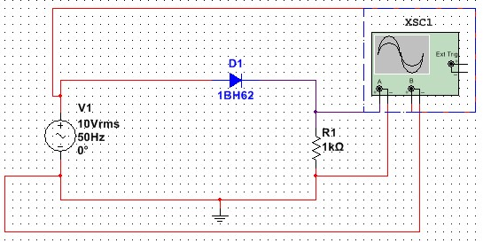

**Graph :**

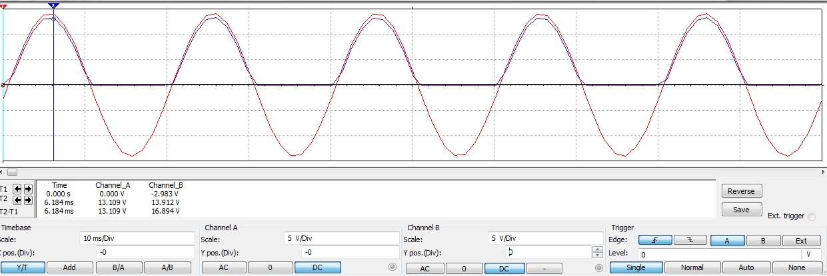

**2. Full Wave Rectifier :**

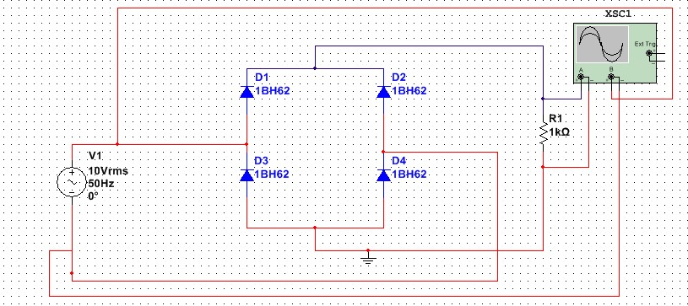

**Graph :**

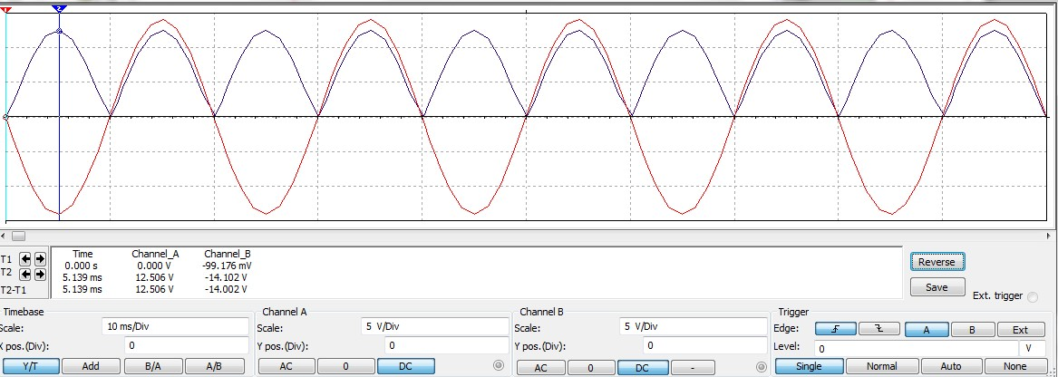

**Results & observations :**

**Theoretical values :**

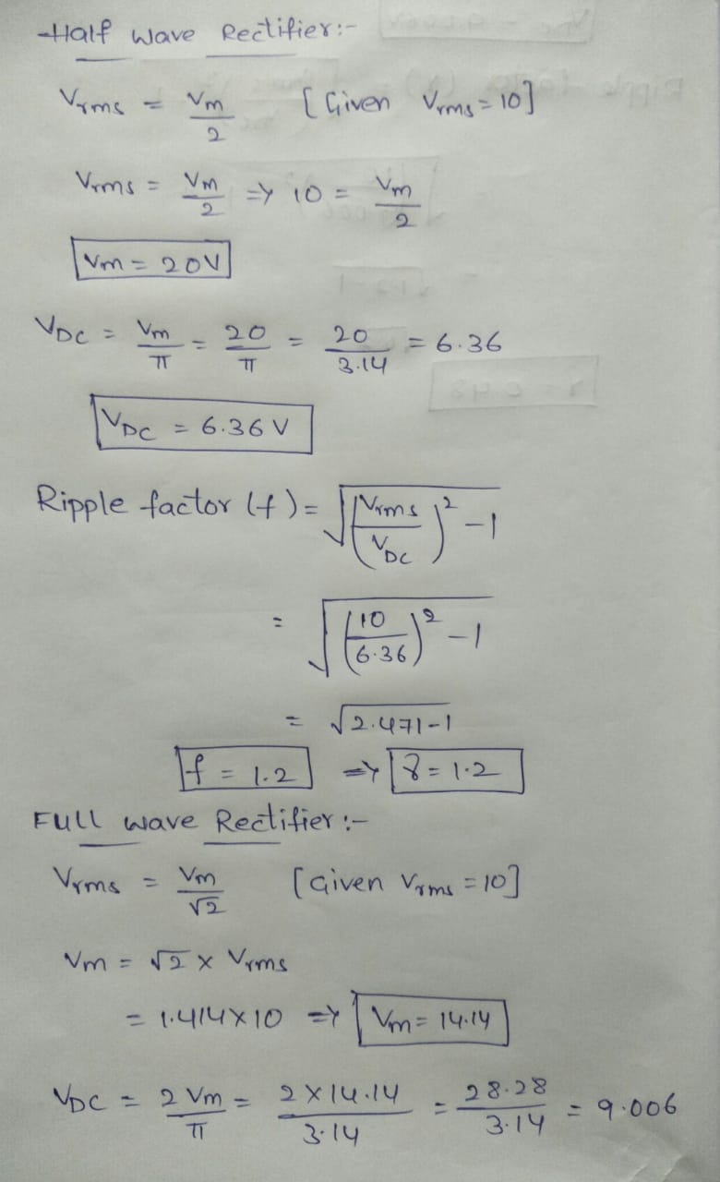

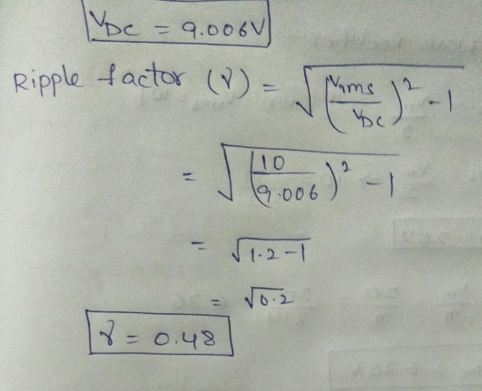

|  |  |  |  |  |  |  |  |  |
| --- | --- | --- | --- | --- | --- | --- | --- | --- |
|  | **Vm** | | **Vrms** | | **VDC** | | **γ** | |
| **Halfwave**  **Recti fier** | **Theore tical** | **Multi sim** | **Theore tical** | **Multi sim** | **Theore tical** | **Multi sim** | **Theore tical** | **Multi sim** |
| 20V | 13.18 1V | 10V | 6.590V | 6.36V | 4.195 V | 1.2V | 1.2115 V |
| **Fullwave**  **Recti fier** | **Theore tical** | **Multi sim** | **Theore tical** | **Multi sim** | **Theore tical** | **Multi sim** | **Theore tical** | **Multi sim** |
| 14.14V | 12.50 6V | 10V | 8.84V | 9.006V | 7.961 V | 0.48V | 0.483 V |

#### EXPERIMENT NO. : 9

**Objective :** To study the MOSFET amplifier working in common source configuration with given specifications.

**Software Used :** NI MULTISIM

**Theory :**

The MOSFET structure has become the most important device structure in the electronics industry. It dominates the integrated circuit technology in Very Large Scale Integrated (VLSI) digital circuits based on n-channel MOSFETs and Complementary n channel and p-channel MOSFETs (CMOS). The technical importance of the MOSFET results from its low power consumption, simple geometry, and small size, resulting in very high packing densities and compatibility with VLSI manufacturing technology. Two of the most popular configurations of small-signal MOSFET amplifiers are the common source and common drain configurations. The common source circuit is shown below. The common sources, like all MOSFET amplifiers, have the characteristic of high input impedance. High input impedance is desirable to keep the amplifier from loading the signal source. This high input impedance is controlled by the bias resistors R1 and R2). Normally the value of the bias resistors is chosen as high as possible. However, too big a value can cause a significant voltage drop due to the gate leakage current. A large voltage drop is undesirable because it can disturb the bias point. For amplifier operation the MOSFET should be biased in the active region of the characteristics.

**Circuit Diagram:**

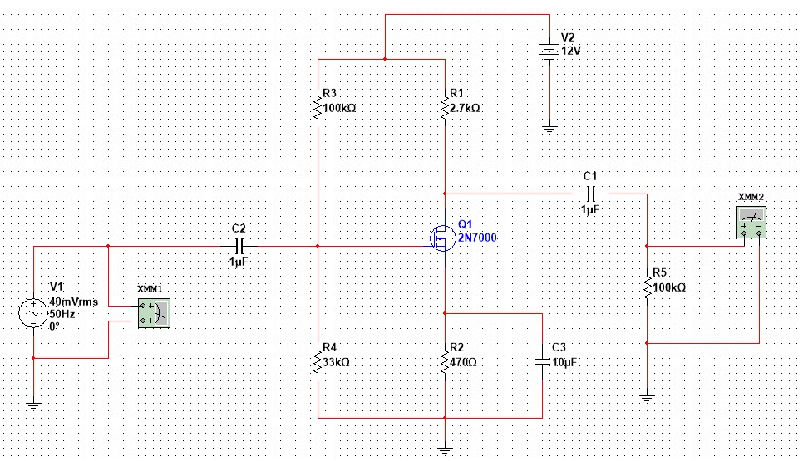

**Results & Observations :**

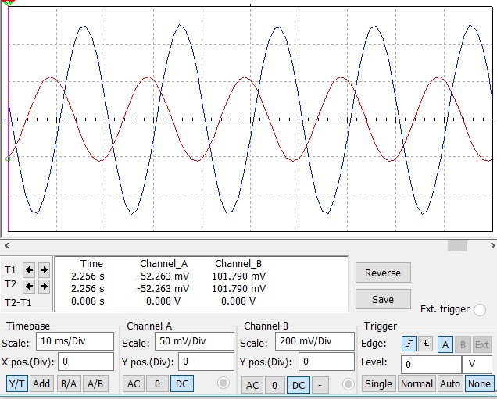

|  |  |  |
| --- | --- | --- |
| **Input voltage**  **Vi**  **(mV)** | **Output voltage**  **Vo**  **(mV)** | **Voltage gain**  **Vo/Vi** |
| 40.016 | 355.725 | 8.88956 |
| 50.016 | 442.937 | 8.85590 |

The MOSFET successfully works as a voltage amplifier. we can say that MOSFET gives a gain of voltage 8.8volts that is nearly 9volts.

**EXPERIMENT NO. : 10**

**Objective :** To Verify Thevenin’s theorem.

**Software Used :** NI Multisim

**Theory :**

Any linear, bilateral network having a number of voltage, current sources and resistances can be replaced by a simple equivalent circuit consisting of a single voltage source in series with a resistance, where the value of the voltage source is equal to the open circuit voltage and the resistance is the equivalent resistance measured between the open circuit terminals with all energy sources replaced by their ideal internal resistances.

* **“ Thevenin’s Theorem** states that any complicated network across

its load terminals can be substituted by a voltage source (VTH) with one resistance (RTH) in series **” .**

* This theorem helps in the study of the variation of current in a particular branch when the resistance of the branch is varied while the remaining network remains the same.

**CIRCUIT DIAGRAM**

**:**

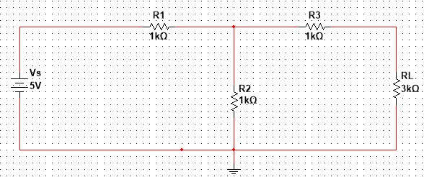

**For calculation of Vth :**

**For calculation**

**of R**

**th**

**:**

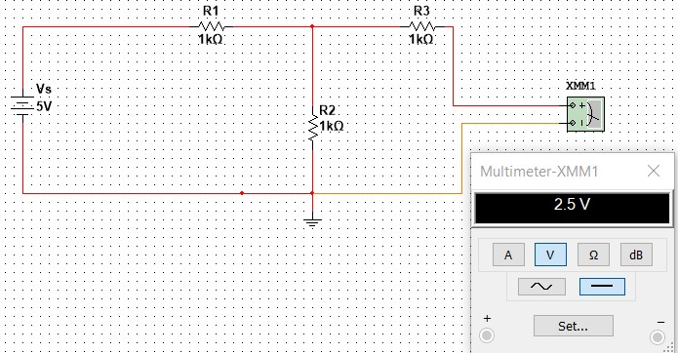

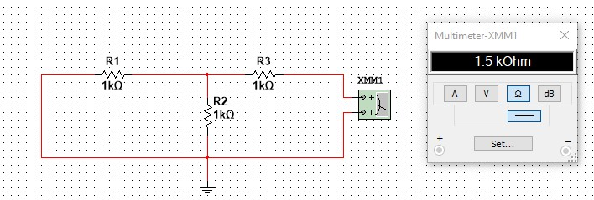

**RESULTS & OBSERVATIONS :**

|  |  |  |  |  |  |  |  |  |  |  |  |  |  |  |  |  |  |  |  |  |  |  |  |  |  |  |  |  |  |  |  |  |  |
| --- | --- | --- | --- | --- | --- | --- | --- | --- | --- | --- | --- | --- | --- | --- | --- | --- | --- | --- | --- | --- | --- | --- | --- | --- | --- | --- | --- | --- | --- | --- | --- | --- | --- |
| **Source Voltage(V**  **s)** | | | | **R1 (Ohm)** | | |  |  | **R2(** |  | |  | **R3(** |  | |  | **Vth(Theo** | | |  |  | **Vth(Mul** | | |  |  | **Rth(Th** | |  |  | **Rth(M** |  | |
| **Oh**  **m)** | **Oh**  **m)** | **retical value)** | | | **tisim value)** | | | **eoretic al)** | | **ultisim)**  **(Ohm**  **)** |
|  | **5V** |  | |  | 1K |  |  |  | 1K |  | |  | 1K |  | |  | 2.5V |  | |  |  | 2.5V |  | |  |  | 1.50K |  | |  | 1.50K |  | |
|  | **5.5V** | |  |  | 2K |  |  |  | 1.5K | |  |  | 1.2K | |  |  | 2.357V | |  |  |  | 2.357V | |  |  |  | 2.057K | |  |  | 2.057K | |  |
|  | **6.2V** | |  |  | 1.3K | |  |  | 1.5K | |  |  | 1.2K | |  |  | 3.321V | |  |  |  | 3.321V | |  |  |  | 1.896K | |  |  | 1.896K | |  |
|  | **7.1V** | |  |  | 1.3K | |  |  | 3K |  | |  | 2.2K | |  |  | 4.953V | |  |  |  | 4.953V | |  |  |  | 3.107K | |  |  | 3.107K | |  |
|  | |  | |  |  | |  | |  | |  | |  | |
| **8V** | | | | 1.4K | | |  | 3.2K | | | | 2.4K | | | | 5.565V | | | |  | 5.565V | | | |  | 3.374K | | | | 3.374K | | | |